Bar Hopper C4 Architectural Model

Jacqueline Ramos, Will DeRoberts, Mark Paris, Diaeddin Motan

September 29, 2021

## Level 1: System Context Diagram

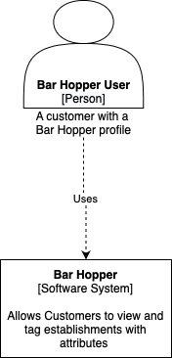

## Level 2: Container Diagram

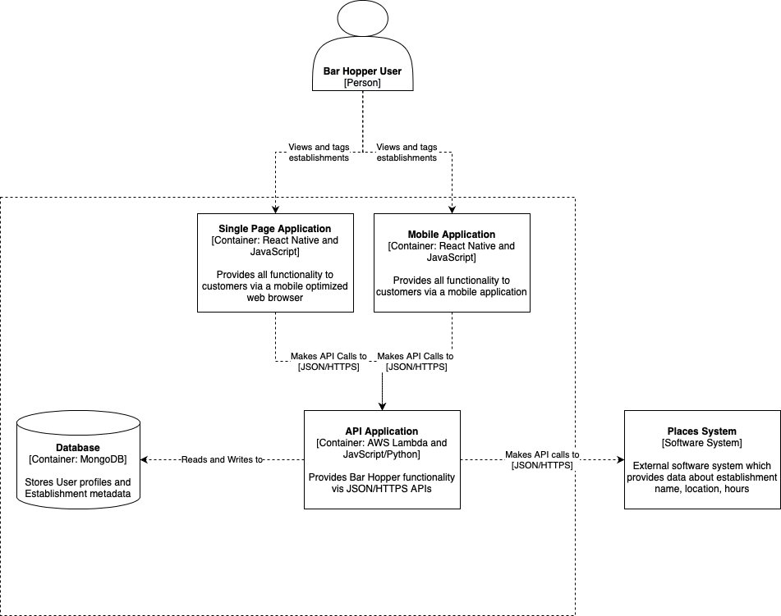

## 

## 

## Level 3: Component Diagram

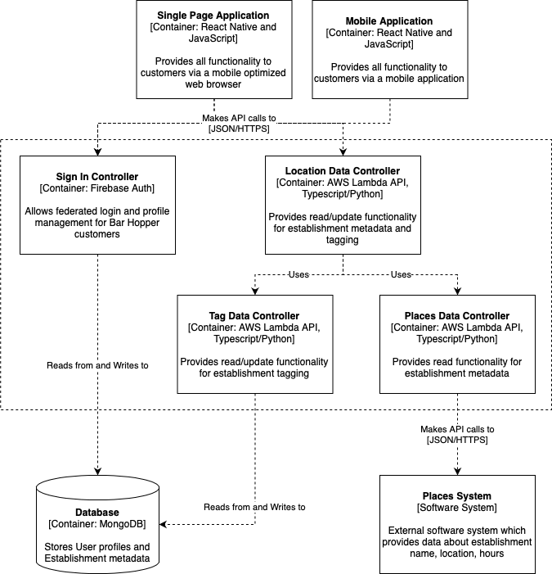

## 

## Level 4: Code

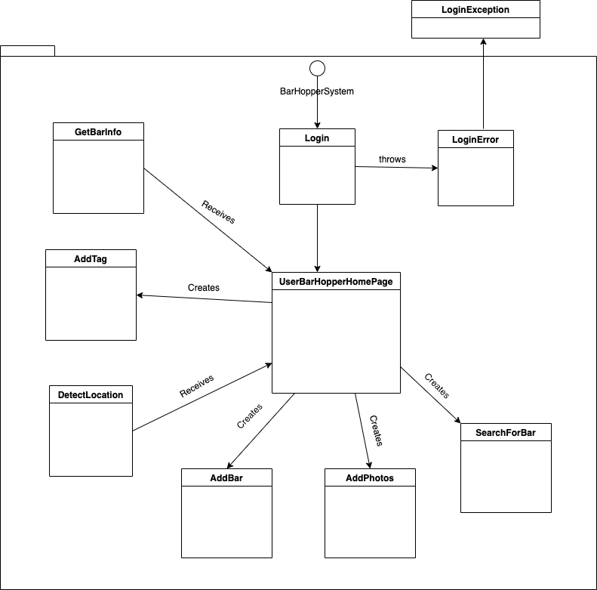

## Physical View

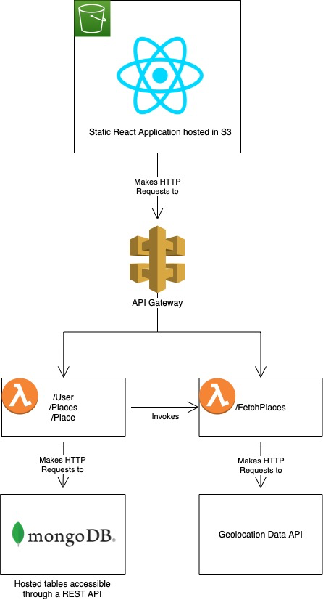

## Development/Deployment View

